**Graphical Repeater RTD-150E**  **Installer manual**

# Contents

**1 Introduction**

* 1. System planning and design 3
  2. Staff 3

1. **General**
   1. Repeater functions 4
   2. User interface 4
2. **Configuring the unit**

3.1 Configuration on the touch screen 5

* 1. Configuration via the web server 6
  2. Network configuration 8
     1. Ethernet configuration 8
     2. Master/slave configuration 8
  3. Configuring the unit 9
     1. General configuration 9
     2. Communications ports 10
     3. Sounds 11
     4. Actions 11
  4. User levels and factory resetting 12
  5. Configuring areas and maps 12
     1. Adding an area 13
        1. Example of parent area/zone 15
     2. Drawing the area covered by a zone 15
     3. Deleting a zone 15
     4. Deleting a map 16
  6. Adding/deleting maps and icons 16
  7. Backups and updates 16
  8. Devices 18

3.9.1 Device parameters to be configured 18

3.9.2 Adding/deleting/changing devices 19

3.9.3 Importing areas and devices with an .XML file 20

* **1. Introduction**

## 1.1 System planning and design

## It is assumed that the system of which this device is part has been designed by an expert in fire alarm systems, in accordance with the requirements of EN 54 Part 14 (UNE 23007/14) and the other applicable standards.

## The design must clearly show the locations of the control panel and the field devices.

## 1.2 Staff

This product should only be installed by qualified staff.

Carefully read the start-up and configuration procedures in this manual. The manufacturer recommends checking the wiring before connecting anything to the unit. Do not configure anything without fully understanding how it works.

* **2. General**

The **digital repeater** is a peripheral device based on an embedded system which the client can connect to any screen with an HDMI input.

* **2.1 Functions**
* The main panel's repeater: indicating the **Alarms**, **Faults** and Disabled associated with **Zones**.
* To show the location of the **Zones** affected by events on associated **Maps**.
* To show the location of the **devices** that make up the fire alarm system on associated **Maps**.
* Remote functions: **Sounders On**, **Sounders silence, Silenced buzzer and Reset.**
* **2.2 User interface**

The digital repeater has two user interfaces: the **screen** that is connected to the unit and which, if not a touch screen, can be operated using a keyboard and mouse connected to the repeater's USB inputs and a built-in **web server**.

* **3. Configuring the unit**

The repeater can be configured:

1. On the **screen** that is connected to the unit (by touch if it is a touch screen or using a mouse and keyboard that are connected to the unit's USB inputs).
2. Via the unit's built-in **web server**.

Certain options can only be configured on the touch screen, others can only be configured via the web server and others can be configured on both.

* *On the* ***screen****:* you can configure the unit's network options and draw areas on the maps and manage passwords.
* *On the* ***web server****:* you can add drawings and icons, update firmware and perform backups and restores.
* *With* ***both*** *options:* you can configure zones, languages, ports, filters, sound, emails, etc.
* ***3.1 Configuring the unit on the screen:***
* 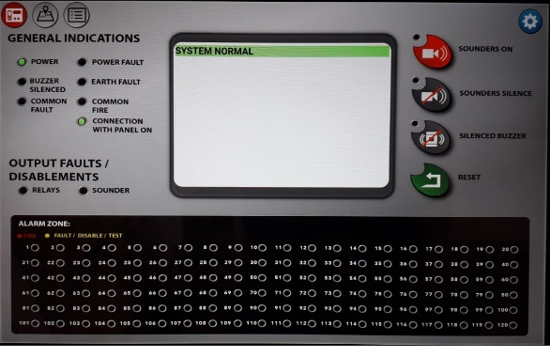Press the button

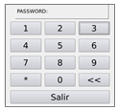

* Enter the **Level 3** password (**2222** by default) on the keyboard that appears.
* Press the “**SYSTEM**” tab.
* To change the various **configuration fields**, you must hover over the text boxes. When you have done this, a keyboard will be displayed:

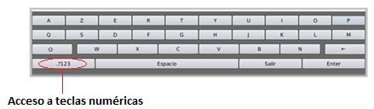

* Depending on the field being configured, only the numeric keys may be usable.
* When the configuration is completed, press **Save configuration**. Certain changes, such as the language or network configuration, require a **reboot** of the unit.
* ***3.2 Configuring the unit with the web server:***

There are two ways to access the web server:

* 1- By connecting the repeater directly to a **PC** via both of their RJ-45 connectors, using an Ethernet cable.
* 2- By connecting the repeater to a **LAN** (via the Ethernet connection) and accessing it on any **PC** that is connected to it. If there is an active DHCP server on the network, the unit will **automatically configure** its network settings (provided that this option is enabled in the unit's configuration). To find out what IP has been configured in the repeater at any time (on both networks, Ethernet and Wi-Fi) enter the system's configuration screen and it will be shown.

The repeater's **default ethernet network configuration** is: **IP 192.168.1.200 Gateway 192.168.1.1 Mask 255.255.255.0**

* 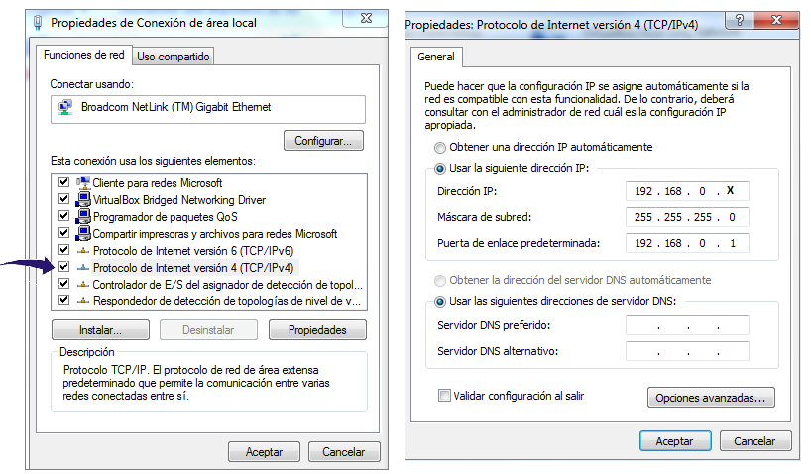In either of the two above cases, the repeater and the **PC** must be in the **same IP range** for communication to be possible. To check and, if necessary, change the PC's IP address to connect it to the unit for the first time, you must check the configuration of your PC's network adapter:
* **Control panel -> Network configuration (Network and sharing centre in W7) -> Local area connection (Change adapter settings + Local area connection in W7) -> Right click on this option -> Properties**
* Check the “Internet Protocol” option. The configuration should be as it appears in the above picture, with **X** being any integer between 1 and 254 (always something other than the gateway (which is the router), 200 which is the default repeater gateway number and those used by the other active units in the network).
* To connect to the **web server**, open any browser on the PC and enter the following in the address bar:

[**http://IP**](http://IP) **of the repeater** **(by default http://192.168.1.200)**

* To access the repeater's configuration screen: while on the web server, press the **Configuration** tab.
* ***3.3 Configuring the repeater's network***

You can configure it on the screen or on the web server.

* + **3.3.1 Ethernet configuration**

Enable IP communication and configure as follows:

* **Automatic eth IP (DHCP)**: Enable/disable DHCP
* **Eth IP:** Enter the IP address that your unit will have.
* **Eth Netmask:** Configure the subnet mask.
* **Eth gateway:** Enter the router's IP address.
* **Eth DNSs:** Configure the DNS server.
  + **3.3.2 Master/slave configuration:**

In any given installation, configure **a single unit as the master**; this will communicate with the panel. The other devices will be **slaves** and they will be managed by the **master**. The master will monitor the slaves' connections and will show any enabled repeaters that have been disconnected/reconnected on all units.

* ***In the case of a master device:***

**Type of device:** Master

**IP/Name remote master device:** There is no need to configure anything.

**Master TCP port:** Port to access this unit (20010 by default)

**Repeater name:** Name of unit to be monitored.

**List of names of repeaters to be monitored:** List of the names of the slave repeaters, separate by commas.

* ***In the case of a slave device:***

**Type of device:** Slave

**IP/Name remote master device:** IP of the master

**Master TCP port:** Port of the master (20010 by default)

**Repeater name:** Name of unit to be monitored.

* ***3.4 Configuring the unit***
  + **3.4.1 General configuration:**
* **Language:** Select the unit's language.
* **Screen off time:** Time before the screen goes into sleep mode due to inactivity. From 0 to 65,000 seconds.
* **Zone filtering:** The device allows you to filter zones and only show the ones configured here. Use the tag **p(panel)+panel number+z(zone)+zone number** to enter the panel and zone numbers. Use commas “**,**” to separate the tags and you can use dashes “**-**“ to specify ranges of zones. **z0** includes **all events with no assigned zone** and all system events. Examples:

p1z2 -This will filter zone 2 of panel 1

p1z2,p3z4 -This will filter zone 2 of panel 1 and zone 4 of panel 3.

p2z4-z7 -This will filter zones 4 to 7 of panel 2

p3z0-z255 -This will filter all of panel 3's events, including those with no assigned zone.

* **Disable display of system events not associated with zones:**  this allows you to disable the displaying of events that are not associated with any zones. This will apply to all of the network's panels.
* **Upload master data (areas, maps, devices):** If you enable this option, every time that you restart the master unit, the slaves will receive all of the **maps**, **areas** and **devices** configured in this unit. This allows units to be configured in installations with more than one device, when the units work with the same data: they are configured on the master and the slaves receive the configuration.
* **3.4.2 Communications ports:**
* **Local panel number (only network of panels):** for a network of panels, enter the number of the panel to which the master is connected.
* **Modbus panel number:** number of the panel to which the device is connected.
* **Modbus port speed:** speed of communications with the Modbus port.
* **Panel protocol:** 1 or 2.
* **Key 1**: key to change protocol1.
* **Key 2**: key to change protocol2.
* **3.4.3 Sound:**
* **Enable sound for Alarm:** Activate/deactivate the unit's warning sound in the event of alarms.
* **Enable sound for Fault:** Activate/deactivate the unit's warning sound in the event of faults.
* **Centralised silence:** If this is ON, when the buzzer on the panel or any of the network's units are silenced, all units will be silenced.
* **3.4.4 Action:**
* **Enable Demo (if it is the master)::** Allows DEMO mode to be enabled for *master* units. It is **enabled** with this option and it is **activated** on the System configuration screen with the *“Start Demo”* button. To exit this mode, simply press *“Stop Demo”*. This option can only be enabled for master units, but if it is enabled, you can activate/deactivate demo mode on any slave associated with that master unit. While in *demo mode*, alarm and fault signals will automatically be generated and maps and preloaded areas will be activated so that the power of these units can be shown without needing to connect to a panel.

The unit allows an **email** to be sent to one or more recipients in the event of an **Alarm** and/or **Fault**. The parameters that you should configure are:

* **SMTP server authentication:** Authentication has to be enabled for some mail servers (e.g. **Gmail**). When this is the case, this option must be activated and you must enter the **User** and **Password** (in the case of Gmail, this will match the email user and password).
* **SMTP Mail Server:** Configure the information that the SMTP server provides (**smtp.gmail.com** in the case of **Gmail**)
* **Email:** The repeater's email address.
* **TLS Encryption:** Activate this if the mail server uses it (activate it with **Gmail**).
* *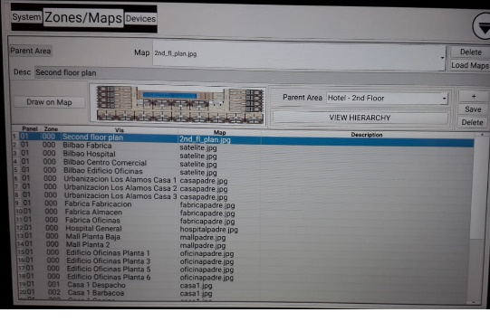***Destination emails for alarms:** Configure the destination email addresses, separated by commas.
* **Destination emails for faults:** Configure the destination email addresses, separated by commas.
* **ID connected panel:**
* 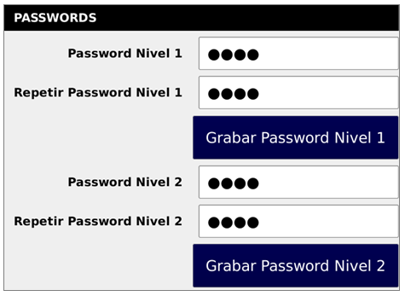***3.5 Access levels and factory resetting***

The repeater has 2 access levels. Passwords must be changed on the configuration menu of the unit's touch screen.

* **Level 2:** Default password 1111. Allows you to perform actions with the panel (resetting, silencing, etc.).
* **Level 3:** Default password 2222. Allows you to access the **Unit's configuration**, **Zone configuration**, **Devices** and the **Web server**.
* **Factory reset:** this allow you to return the unit to its original values (unit configuration, areas, events log, etc.).
* **Remote assistance:** Only press this option if requested to do so by the manufacturer.
* **Ping:** You can check the unit's connection by testing a numeric/non-numeric IP.
* ***3.6 Configuring areas and maps***
* **Areas** and their association with Maps are added/deleted on the **touch screen**.
* The associated Maps, Videos and Icons must have been uploaded beforehand.
* Press and enter the **Level 3** password (**4321** by default).
* Press “Zones/Maps”.
* On this screen you can view a list of the areas with all of their information or, if you press “View hierarchies”, you will see the areas in tree format with the established hierarchies, for ease of configuration.
  + **3.6.1 Adding an area**

An **area** is a zone on the map of your facility. It may be composed of one or more sectors on that map. The area may belong to one of the Panel's Zones, or it may be used as a Parent Area to connect maps.

When you press “Parent Area”, the Panel and Zone options are hidden. To add a new area, press the **“+”** button.

* **If it is a Parent Area:**
* Select the associated **Map** (previously added on the web server - see Annex 2).
* Select the associated **Video** (previously added on the web server - see Annex 2).
* You can link this area to another, configuring this in the **Parent Area.**
* **If the Area is associated with a Panel's Zone:**
* Select the Panel Number and Zone Number associated with this area.
* Select the associated **Map** (previously added on the web server - see Annex 2).
* Select the associated **Video** (previously added on the web server - see Annex 2).
* You can link this area to another, configuring this in the **Parent Area.**
  + - **Example of a Zone's Area and a Parent Area:**
* 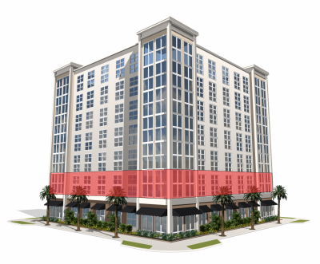A building's fire alarm system. This is configured so that the detectors on each floor are associated with different zones.

**Add Parent Areas (not associated with zones):**

1. Add an area (Area 1). This corresponds to the map of the building. Draw the sector that covers the 1st floor.

This is a parent area with no panel or zone. It is not associated with any Parent Area (although you could/can locate the building within a city).

1. Add an area (Area 2). This corresponds to the map of the building. Draw the sector that covers the 2nd floor.

This is a parent area with no panel or zone.

….

And so on with the rest of the floors.

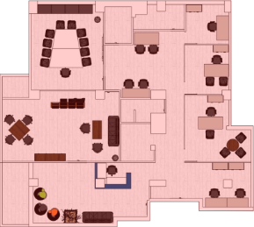**Add areas of zones:**

1. Add an area (Area 15) that is associated with zone 1. This corresponds to the building's 1st floor. The map is of the 1st floor.

**Panel: 1 Zone: 1** . Area 1 will be its parent area (this corresponds to the map of the building in which you marked out the 1st floor).

1. Add an area (Area 16) that is associated with zone 2. This corresponds to the building's 2nd floor. The map is of the 2nd floor.

**Panel: 1 Zone: 2** Area 2 will be its parent area (this corresponds to the map of the building in which you marked out the 2nd floor).

….

And so on with the rest of the zones.

* + **3.6.2 Drawing the area covered by a Zone on a map**
* 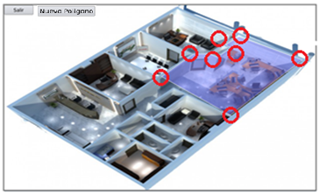Press “Define Map”
* Mark the **corner points** of the **sector** to mark out the Zone on the Map. To make sure that you are accurate, it is best to connect a mouse to the USB hub to draw them. For each unit it is possible for more than one zone to overlap in a single area, with different colour intensities being used to distinguish between each zone if any events occur in these overlapping zones.
* The unit will draw the sector.
* If you want to add other areas for this zone, press “New Poligon”and draw the following sector.
* If you want to redraw the area, exit this screen without saving and then press “Define map” again.
* When the zone is fully configured, press “Save”
  + **3.6.3 Deleting a zone**
* Select the **Zone**.
* Press “Delete”. To exit the “Zones” menu, press 
  + **3.6.4 Deleting a map**

Select the map from the “Map” list. Press the "Delete” button on the right.

* ***3.7 Adding/deleting maps and icons***

**Maps:** These will be the maps that are to be associated with the system's Areas. You can configure several Areas on a map. Each Area is associated with a single map. You can use JPEG or PNG formats (we recommend JPEG maps with optimal resolution).

They can be added on the web server (Maps) or from the Configuration screen (Zones/Maps), by connecting a pen drive containing the maps on its root directory and pressing the “Upload maps” button.

**The names of the maps must not contain any spaces. To avoid any problems, always use lowercase letters, dashes and underscores.**

On the system's configuration menu, you can **optimise** the maps after they have been added. To do this, in the text box at the end of the screen type “optimize” and press the “Engineer” button. The PNG maps will automatically be converted to JPEGs and to a 1200 resolution (preserving the aspect ratio).

* + ***3.8 Backups and updates***

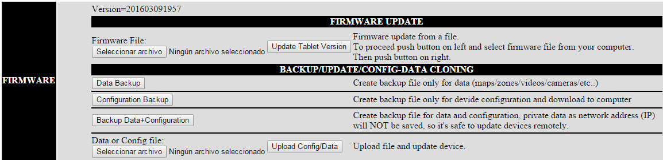

It is simple to make backups of the unit's information and to update its firmware version. To do this, go to the web server and then select the “Firmware” option. The firmware version that is installed will be shown at the top.

* **To update the Firmware version (Firmware Update):**

Press “Select file”. On the browser that appears, search for the update file (firm...).

Press on “Update Tablet Version”. Wait for the unit to restart.

**PLEASE NOTE!!: When you update the firmware version, bear in mind that sometimes it is necessary to perform the update in two stages. The firmware version consists of two digits. The first digit indicates a significant change in the unit's functionality, and the second is for version updates. To update to a version where the first digit changes, you must first perform the X.0 version update. In other words: if you are changing from version 2.5 to 3.2, you must first update to version 3.0 and then to 3.2.**

* **To perform a data backup/restore:**

This includes the configuration of Areas and Devices.

**Backup->**Press on “Data Backup”. In the browser that appears, select a name for the backup and a place to save it.

**Restauración (Restore)->** To restore a data backup on the unit, press on “Select file” and select the data backup file being restored in the browser. Finally, press on “Upload Config/Data”.

* **To back up/restore a configuration:**

This includes the device's configuration (excluding the network configuration).

**Backup->**Press on “Configuration Backup”. In the browser that appears, select a name for the backup and a place to save it.

**Restore->** To restore a data backup on the unit, press on “Select file” and select the data backup file being restored in the browser. Finally, press on “Upload Config/Data”.

* **To back up/restore a configuration and data:**

This includes the unit's configuration (excluding the network configuration) and the configuration of Areas.

**Backup->**Press on “Backup data + Configuration”. In the browser, select a name for the backup and a place to save it. **Restore->** Press on “Select file” and select the data+configuration backup file being restored in the browser. Finally, press on “Upload Config/Data”.

* + ***3.9 Devices***

******The digital repeater allows you to locate various types of devices on the maps, in the form of icons, and associate them with an area.

To configure them, press on and on the **“Devices”** tab.

* + **3.9.1 Device parameters to be configured**
* **Description:** The description that you give to the device.
* **Area:** Area to which the device belongs.
* **I Normal:** The file containing the icon associated with that device when it is in “standby” mode. Icons can be added from the web server.
* **I Fault:** The file containing the icon associated with that device when it is in “fault” mode. Icons can be added from the web server.
* **I Alarm:** The file containing the icon associated with that device when it is in “alarm” mode. Icons can be added from the web server.
* **Video:** Video file associated with the device.
* **Panel/Loop/Zone:** The device's Panel/Loop/Zone.
* **Type:** Types of devices: detectors, modules, sounders or flashing alarms, cameras, touch screen devices, panels, repeaters, fire extinguishers, etc.
* **Model:** Subdivision of device type.
* **Aux:** (Reserved for certain units)
* **Place:** Allows you to locate the device in the selected area. You can select its size by sliding the zoom bar.
  + **3.9.2 Adding/deleting/changing a device**
* **Adding:**

If you press **“Add”**, the repeater will add a device of the kind that you have selected and it will place it at the bottom of the list of devices.

When you have adjusted the new device's parameters, press **“Change”** to save the changes.

* **Changing:**

Select the device being changed from the list at the bottom. Press **“Change”** to save the changes.

* **Deleting:**

Select the device being deleted from the list at the bottom. Press **“Delete”.**

* + **3.9.3 Importing areas and devices with an .XML file**

If you have a file with the panel's configuration in .xml format, you can import that data to the system. Connect a pen drive to one of the USB inputs of the master device that contains the file. Press on “Import XML” and the areas and devices contained on the file will automatically be completed. Any previous areas will be overwritten. You should only: -For the Areas: select the associated maps and draw the sectors on the maps.

-For the devices: locate the device on the map.